1. Local applications:

Runing steps:

(1) SOAP API – SoapService (use glassfish)

(2) Admin Application – Admin

(3) REST Service – RESTService

(4) Frontend Content Application - user-end

(A react application, run npm install and then npm start)

(5) Database

|  |
| --- |
|  |
| jdbc:oracle:thin:@calvin.humber.ca:1521:grok","N01308482","oracle"  Used tables: NETFILX2  Colums: |  |

Github:

<https://github.com/maorutian/LoaclSoap>

2. Deployed application:

SOAP API – SoapService (use io.thorntail)

Github:

<https://github.com/maorutian/maorusoap>

Heroku:

<https://soapmaoru.herokuapp.com/>

It looks Deployed.

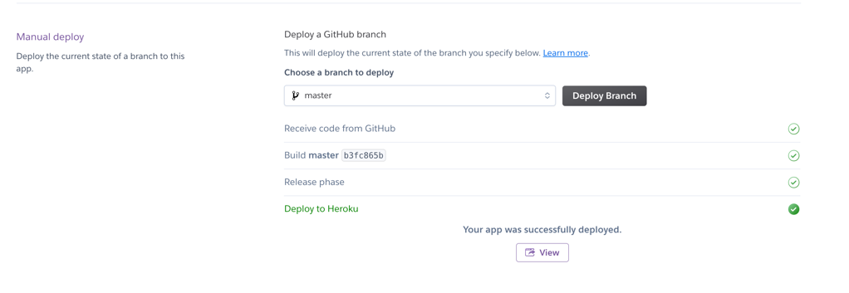

But once I view it I will get an error.

Here is my error:

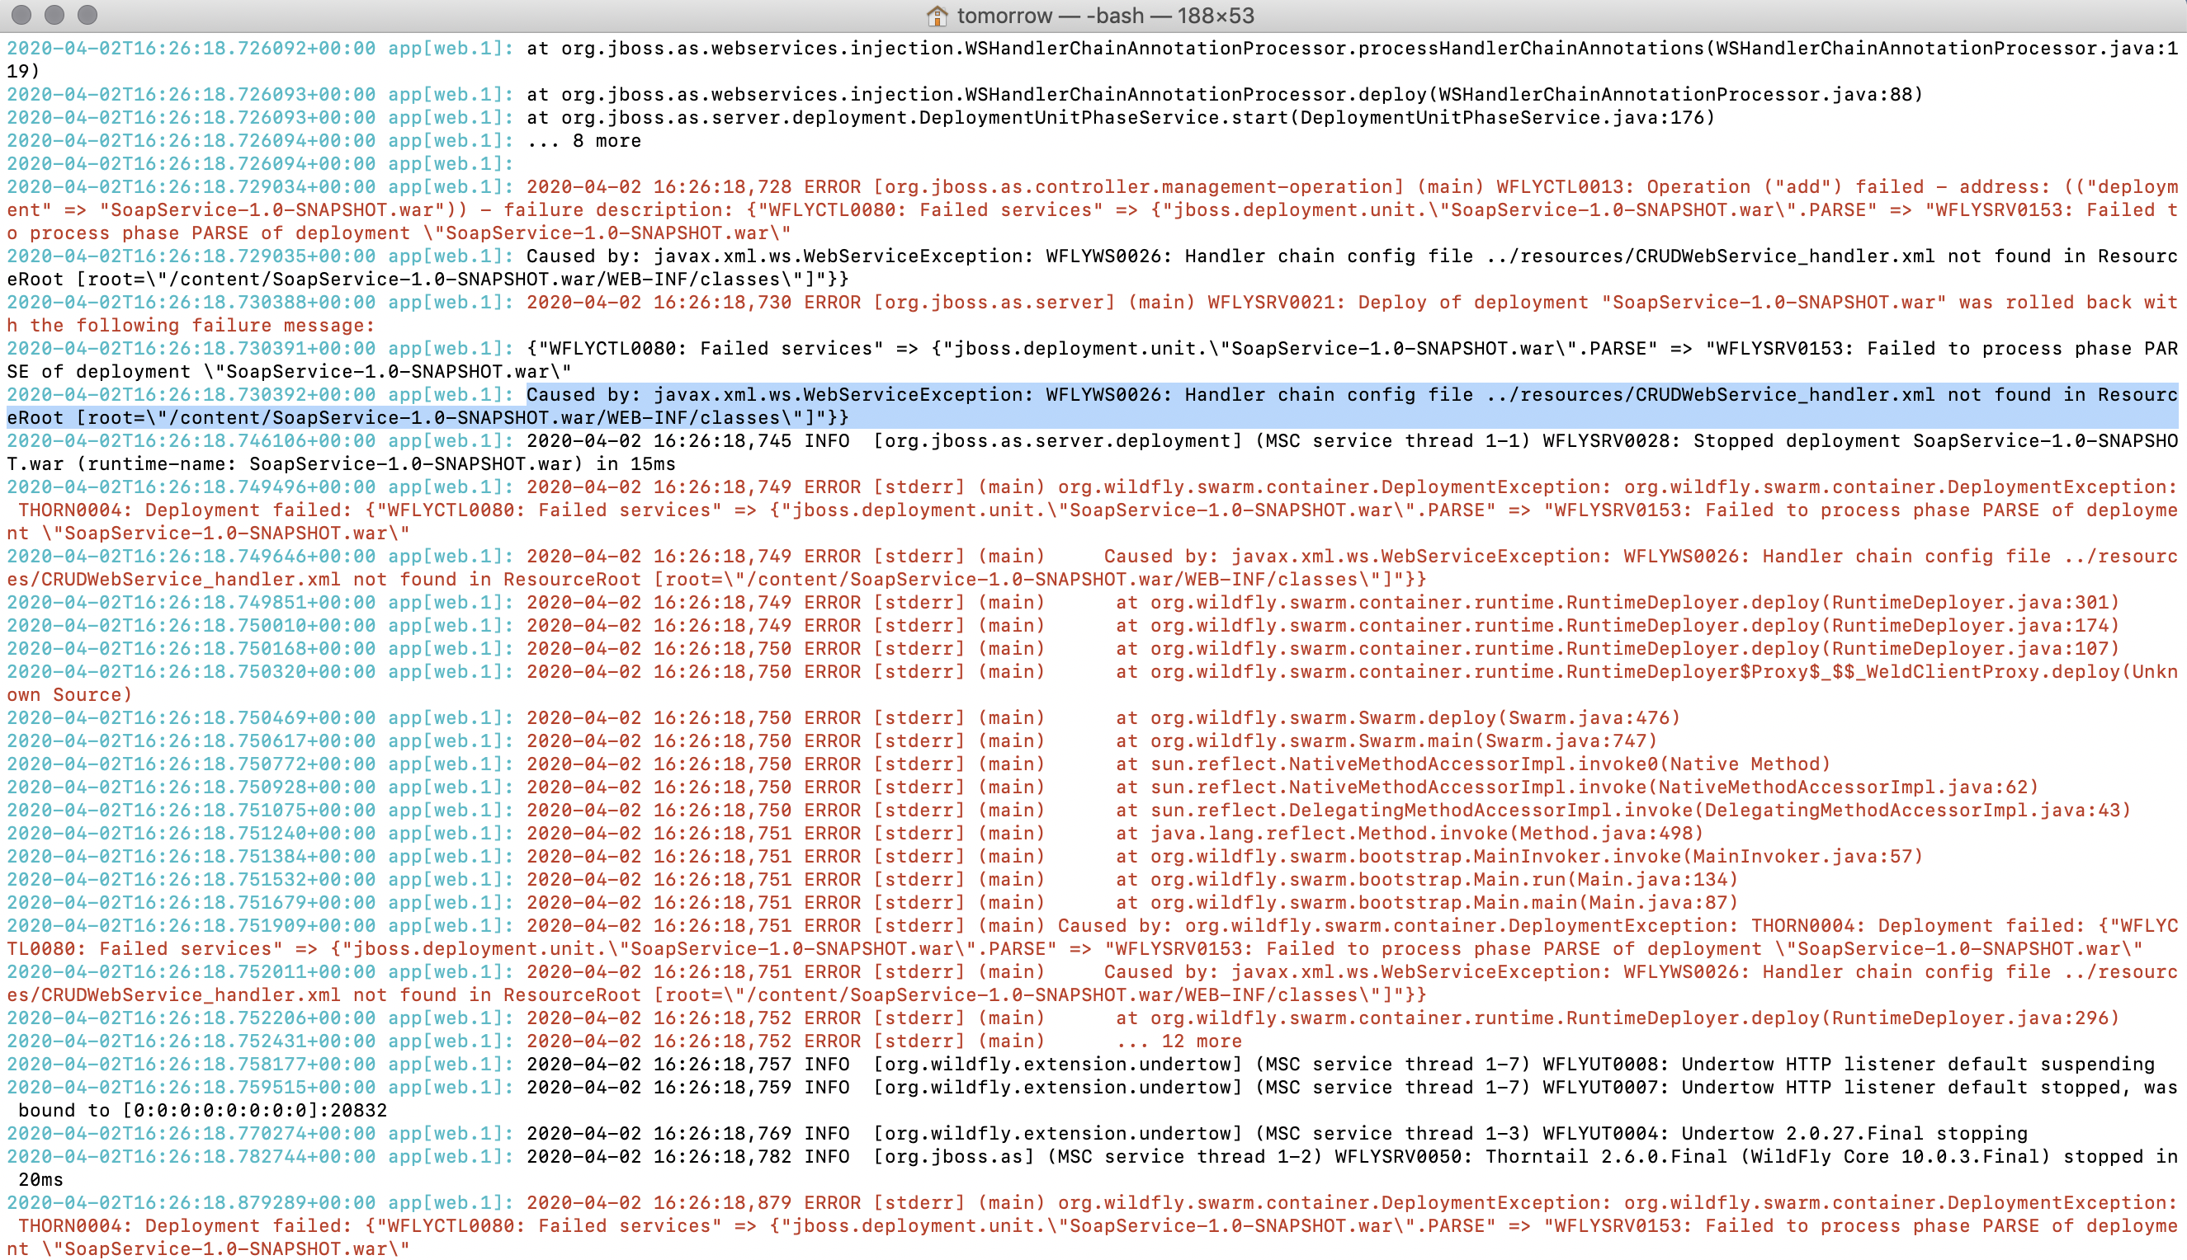

I think it is because it cannot find the hander xml file.

Based on what we I leaned from class, we move the hander xml file under resources folder.

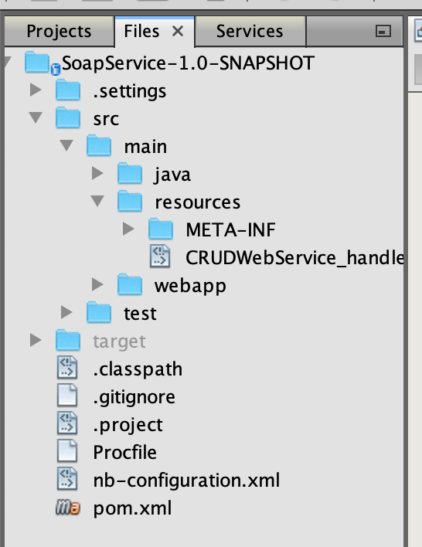

But in service we didn’t change the path. It works when I run local.

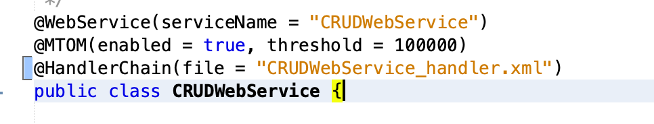

I tried to change the path

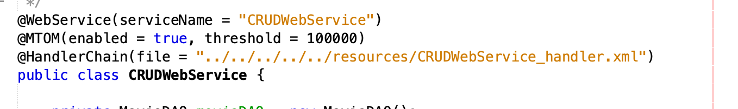

But it still doesn’t work.